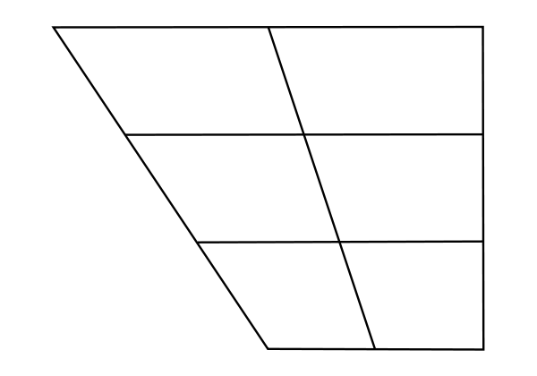

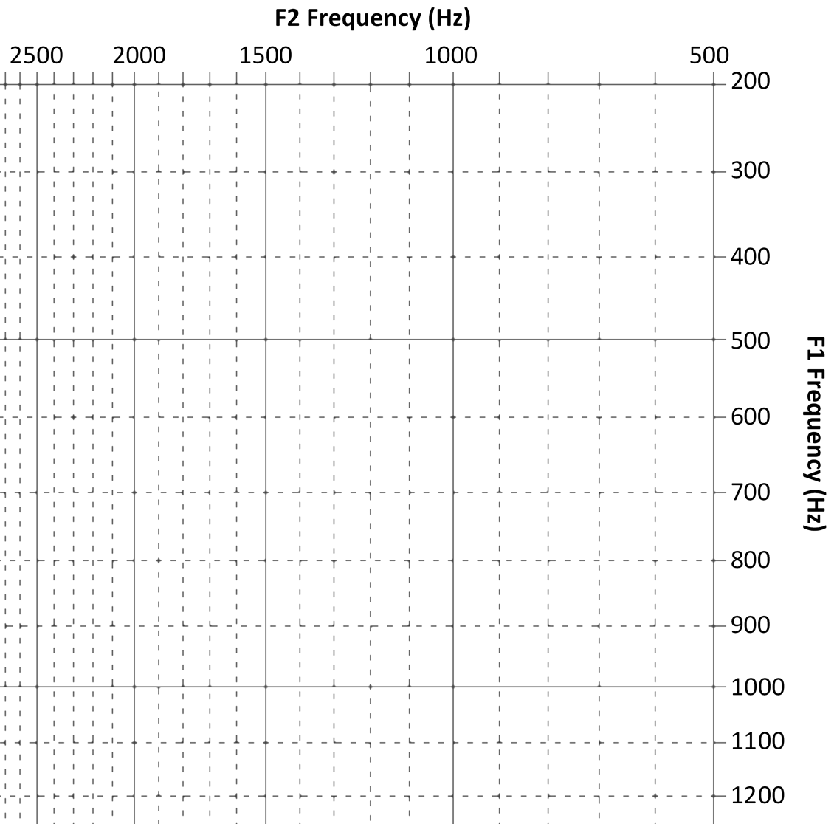

**● examples**

**● right click**

**🡪‘ungroup’ ●**

**move us ●**

**around ●**

**● click ‘group’**

**Copy and ●**

**● paste us**

**with the ●**

**● chart when**

**● you are done.**

**Delete us ●**

**● change us**





2500 2000 1500 1000 500

200

300

400

500

600

700

800

900

1000

1100

1200

**F2 Frequency (Hz)**

**F1 Frequency (Hz)**